28th Sunday in Ordinary Time
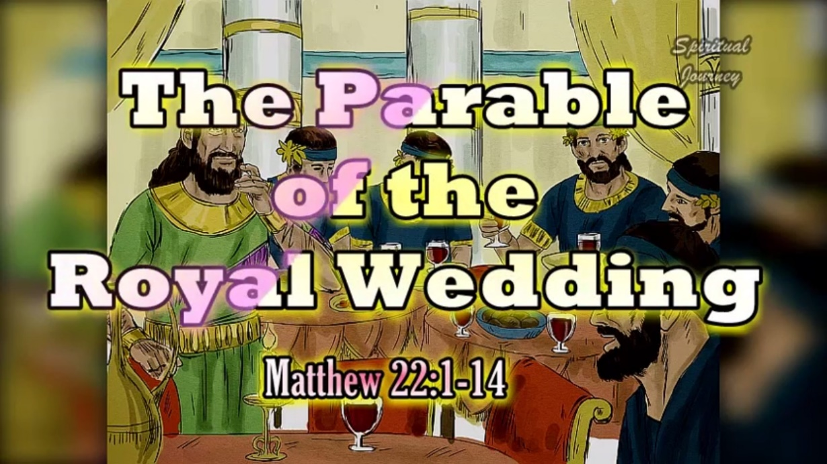

1st Reading: Isaiah 25:6-10
The image of a banquet symbolises the blessings God has in store for His People
On this mountain the Lord of hosts will make for all peoples a feast of rich food, a feast of well-aged wines, of rich food filled with marrow, of well-aged wines strained clear. And he will destroy on this mountain the shroud that is cast over all peoples, the sheet that is spread over all nations; he will swallow up death forever. Then the Lord God will wipe away the tears from all faces, and the disgrace of his people he will take away from all the earth, for the Lord has spoken.
It will be said on that day, Lo, this is our God; we have waited for him, so that he might save us. This is the Lord for whom we have waited; let us be glad and rejoice in his salvation. For the hand of the Lord will rest on this mountain.
Responsorial: Psalm 22
Response: I shall live in the house of the Lord all the days of my life.
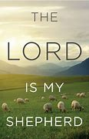
The Lord is my shepherd;
there is nothing I shall want.
Fresh and green are the pastures
where he gives me repose.
Near restful waters he leads me,
to revive my drooping spirit. Resp:
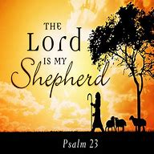
He guides me along the right path;
he is true to his name,
If I should walk in the valley of darkness
no evil would I fear.
You are there with your crook and your staff;
with these you give me comfort. Resp:
You have prepared a banquet for me
in the sight of my foes.
My head you have anointed with oil;
my cup is overflowing. Resp:
Surely goodness and kindness
shall follow me all the days of my life.
In the Lord’s own house shall I dwell
for ever and ever. Resp:
2nd Reading: Philippians 4:12-14, 19-20
St Paul tries not to depend on material things, but trusts in the Lord for what he needs
I know what it is to have little, and I know what it is to have plenty. In any and all circumstances I have learned the secret of being well-fed and of going hungry, of having plenty and of being in need. I can do all things through him who strengthens me. In any case, it was kind of you to share my distress. And my God will fully satisfy every need of yours according to his riches in glory in Christ Jesus. To our God and Father be glory forever and ever. Amen.
Gospel Acclamation: Eph 1: 17, 18
Alleluia, Alleluia!
May the Father of our Lord Jesus Christ
enlighten the eyes of our heart
that we might see how great is the hope
to which we are called.
Alleluia!

Gospel: Matthew 22:1-14
God is like a king who invites us to a banquet. Many refuse their invitation.
Jesus said to the chief priests and elders: “The kingdom of heaven may be compared to a king who gave a wedding banquet for his son. He sent his slaves to call those who had been invited to the wedding banquet, but they would not come. Again he sent other slaves, saying, ‘Tell those who have been invited: Look, I have prepared my dinner, my oxen and my fat calves have been slaughtered, and everything is ready; come to the wedding banquet.’ But they made light of it and went away, one to his farm, another to his business, while the rest seized his slaves, mistreated them, and killed them.
The king was enraged. He sent his troops, destroyed those murderers, and burned their city. Then he said to his slaves, ‘The wedding is ready, but those invited were not worthy. Go therefore into the main streets, and invite everyone you find to the wedding banquet.’ Those slaves went out into the streets and gathered all whom they found, both good and bad; so the wedding hall was filled with guests. “But when the king came in to see the guests, he noticed a man there who was not wearing a wedding robe, and he said to him, ‘Friend, how did you get in here without a wedding robe?’ And he was speechless. Then the king said to the attendants, ‘Bind him hand and foot, and throw him into the outer darkness, where there will be weeping and gnashing of teeth.’ For many are called, but few are chosen.”
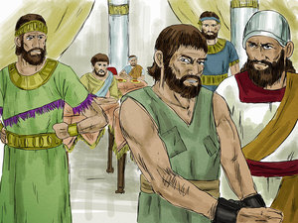

Reflections:
What does tomorrow hold for us? What is there to hope for? Often our imagination projects into the future. As children, we wondered “What will it be like when we grow up?” Parents promised new freedoms and new possibilities “When you are older.” Human nature lives in vital tension between the Already and the Not Yet.
As adults we may indeed have to trim down and focus our hopes and fantasies into more precise channels, with the passing years. But we are still gripped with interest in what lies ahead – not just for oneself and family, but for the wider society and world. What steps in science and technology lie just around the corner? How will society develop, between now and the year 2050? The changing balance between richer and poorer countries; the unstable marital climate of our own nation; proposed educational changes and law reforms; new employment initiatives; the provision of better medical and recreational facilities – all are subject to our keen analysis and hopeful projections.
Elderly people may ponder more on the past than the future and to dwell on by-gone events and treasured relationships. Their looking forward is more often marked with resignation or anxiety than with hope. In the dignity of their mature years, they accept that “Que sera, sera; whatever will be, will be”. And, if they have learned the habit of prayer, they peacefully leave their future in God’s hands.
Today’s Scriptures invite us all to raise our sights, and our hearts, when thinking of the future. Beyond this present life, God has planned a great future for all of us. Isaiah’s prophecy of the heavenly banquet is an invitation to think of our eternal destiny. There is more to live for than what we see in this present world, interesting and challenging though it is. What really counts, indeed, is whether we succeed in reaching our eternal happiness with God.
Perhaps our predecessors in the faith had a stronger sense of the afterlife than we have today. Like Saint Paul, they believed that history is in God’s hands and that divine justice will have the last say. Difficulties in one’s present life could then be seen as growth-pains, or as a means of purifying the spirit from selfishness and sin. Under it all, the world was “in travail,” in process of bringing a new era into existence. So, it was that St Paul – and many other men and women of faith – could be inwardly at peace, no matter how hard the circumstances in which they found themselves. We can “do all things in Him who strengthens us,” if we hold on to the hope of everlasting life.
The eternal banquet must not be abandoned as so much “pie in the sky”! Christians don’t literally expect to sit down to an everlasting meal, an eternal eating and drinking festival somewhere in the stratosphere. While heaven is described in vivid anthropomorphic images, we realise that “eye has not seen.. nor can the human heart imagine, what God has prepared for those who love Him” (1 Cor 2:9). Still, the banqueting atmosphere of friendly conviviality is a good image for that perfect loving communion with God and with others towards which our lives are destined.
Jesus emphasises that this wedding banquet is open to all people indeed, that God sends his messengers out to scour the highways and byways in order to fill his house with guests. It is a comforting thought that God wants us to be saved, even more than we do ourselves.
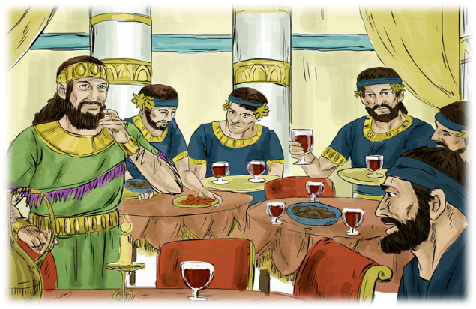
On the other hand, there is a special regalia or wedding garment that must be worn. This is the level of personal commitment required, in order to accept our place at the wedding feast. In other words, we can think and reflect on the community spirit, an ability to share our well-being with other people, in the presence of God. Though founded on faith in God’s creative love, Christian hope retains a strong ethical dimension. Our wedding garment is therefore being woven daily, by the quality of our interaction with others. In this sense, we hold tomorrow in our own hands, as with the help of God’s grace we build our own eternal future. Amen.
